Goals of ST:

<https://www.geeksforgeeks.org/goals-of-software-testing/>

1. Immediate goals:
2. Bug Discovery
3. Bug prevention
4. Long term goals
5. Quality
6. Customer satisfaction
7. Reliablity
8. Risk Management
9. Post implementation goals
10. Reduce Maintainance cost
11. Improve Software Testing process

Software testing

<https://www.geeksforgeeks.org/software-testing-basics/>

Model for ST:

<https://www.ques10.com/p/48600/model-for-software-testing/>

Why Complete Exhaustive Testing is not possible?

1. Time consuming
2. Complex
3. Design Issues
4. Time constraint
5. Different users
6. Testing situations
7. Manual Testing

| **Parameters** | **Exhaustive Testing** | **Effective Testing** |
| --- | --- | --- |
| **Definition** | Test the software for all possible input values. | It tests the effectiveness of an application and tests particular functions for given resources. |
| **Feasibility** | It is practically not possible. | It is possible to test the system. |
| **Time** | It is very exhaustive and time-consuming. | It does not take much time for the testing team. |
| **Approach** | Mostly it is documented and theoretical approach. | It is a completely practical approach and the tester test the effectiveness of the system. |
| **Cost** | It is costly process due to exhaustive nature of checking all testcases. | It is economic and does not extend the budget boundaries of the customer. |
| **Scope** | It is complete testing and covers all possible test scenarios. | It prioritizes test scenarios and smart testing techniques. |

STLC:

<https://www.geeksforgeeks.org/software-testing-life-cycle-stlc/>

1. Requirement analysis
2. Test planning
3. Test Case development
4. Test Environment setup
5. Test Execution
6. Test Closure

Verification and validation

<https://www.geeksforgeeks.org/differences-between-verification-and-validation/4>

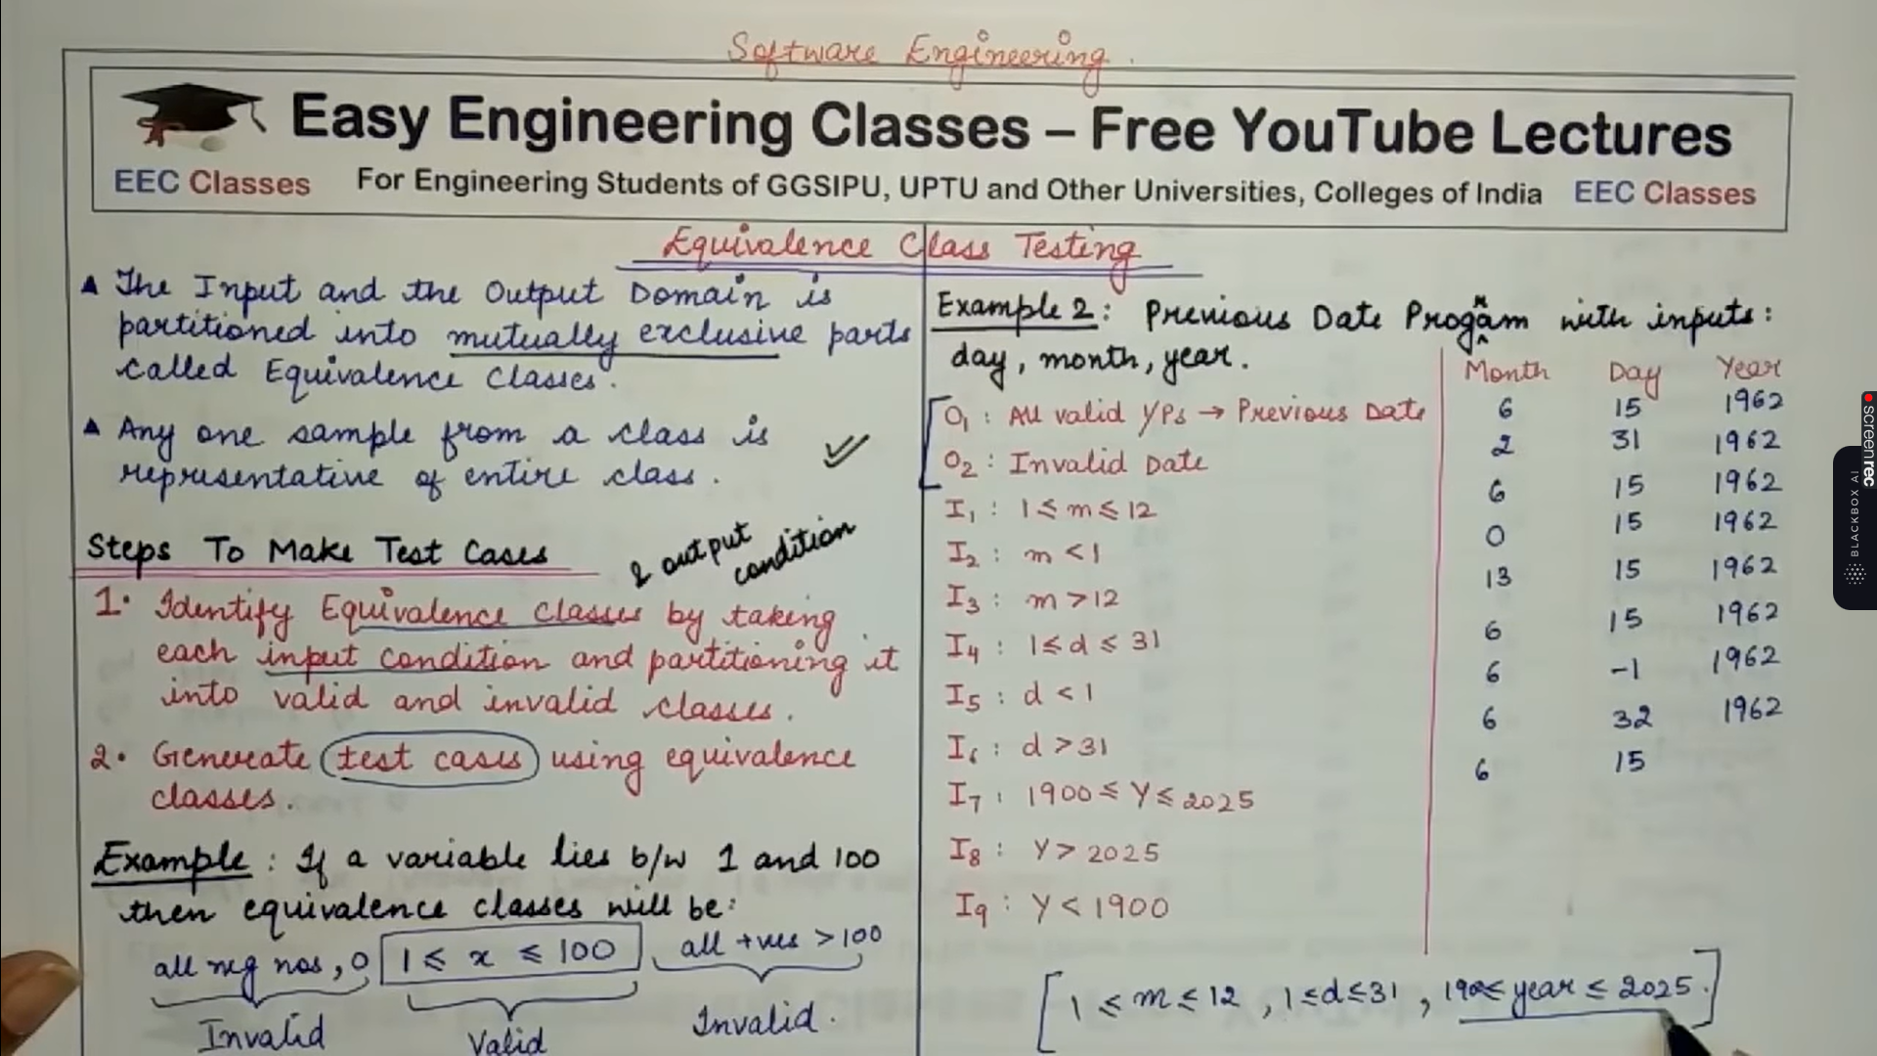



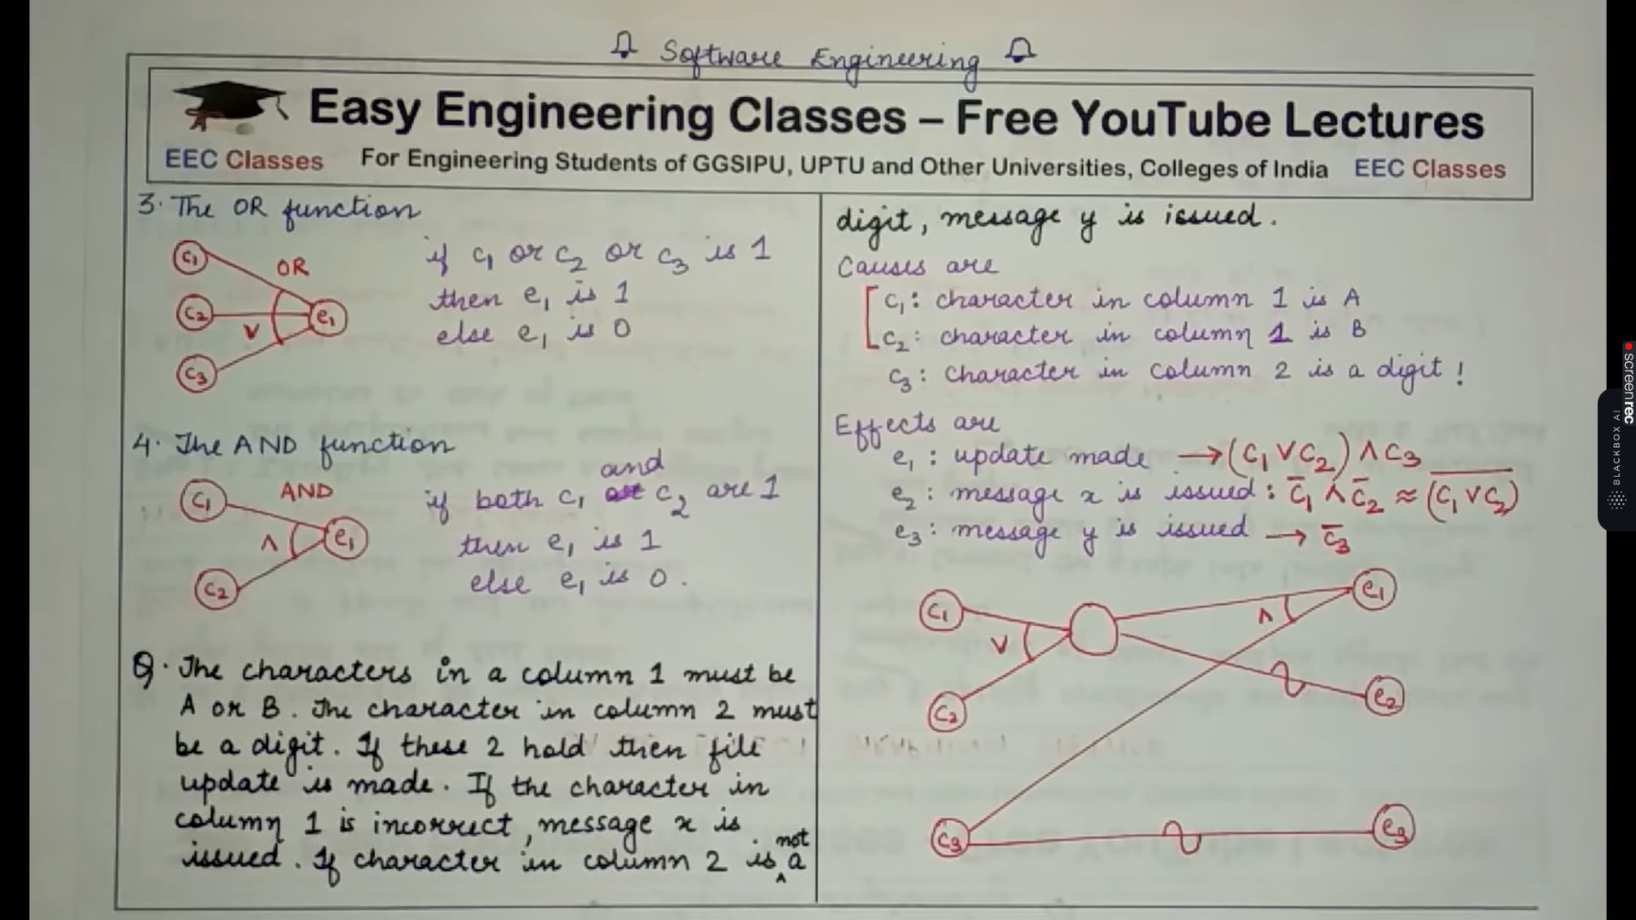

State table based testing

State table-based testing is a technique used in software testing to verify the behavior of a system or software application with respect to its various states and transitions. It is particularly useful for testing systems that exhibit different behaviors or outcomes depending on their internal states. State table-based testing helps ensure that a system transitions between states correctly and that it performs the desired actions in each state.

Here's an explanation of state table-based testing with an example:

**1. Identify the States:**

First, you need to identify all the possible states that the system or software can be in. These states represent the different modes or conditions the system can assume during its operation. Each state should have a clear and well-defined purpose.

**2. Define the Transitions:**

Next, define the transitions between these states. Transitions represent the actions or events that trigger a change from one state to another. You should specify what conditions or events cause the system to move from one state to another.

**3. Create a State Table:**

Once you've identified the states and transitions, create a state table. This table typically has rows for states and columns for transitions. Each cell in the table indicates what action or behavior is expected when a specific transition occurs in a particular state. It can also include additional information, such as expected outputs or error conditions.

**Example: Elevator Control System**

Let's consider an example of an elevator control system:

**States:**

1. Idle

2. Moving Up

3. Moving Down

4. Stopped

**Transitions:**

- Transition 1: User presses the "Up" button

- Transition 2: User presses the "Down" button

- Transition 3: Elevator reaches a floor

- Transition 4: Emergency stop button pressed

**State Table:**

| State | Transition 1 | Transition 2 | Transition 3 | Transition 4 |

|---------------|----------------|----------------|----------------|----------------|

| Idle | Moving Up | Moving Down | Idle | Stopped |

| Moving Up | Moving Up | - | Moving Up | Stopped |

| Moving Down | - | Moving Down | Moving Down | Stopped |

| Stopped | Moving Up | Moving Down | Idle | Stopped |

In this state table:

- If the elevator is in the "Idle" state and a user presses the "Up" button (Transition 1), it should transition to the "Moving Up" state.

- If the elevator is "Stopped" and a user presses the "Down" button (Transition 2), it should transition to the "Moving Down" state.

- When the elevator is "Moving Up" and reaches a floor (Transition 3), it should stay in the "Moving Up" state unless there is a button press for another floor.

- If the "Emergency stop" button is pressed (Transition 4) in any state, the elevator should transition to the "Stopped" state.

This state table serves as a clear reference for testing the elevator control system to ensure that it behaves correctly in different states and transitions, helping identify potential issues and verifying that the system follows the specified logic.

Error guessing technique:





Error guessing is an informal and heuristic software testing technique in which testers use their experience, intuition, and knowledge of the system to identify and test areas of the software that are likely to contain errors or defects. It relies on the tester's intuition and past experience to uncover issues that may not be evident through formal test cases or requirements.

Here's an explanation of error guessing with an example:

**1. Informal Nature:**

Error guessing is not a systematic or structured testing technique like boundary value analysis or equivalence partitioning. Instead, it is based on the tester's experience and intuition.

**2. Tester's Expertise:**

Testers with domain knowledge and experience in testing similar systems are more effective at error guessing. They use their understanding of common pitfalls and issues that can arise in the software.

**3. Lack of Formal Documentation:**

Error guessing doesn't rely on formal test documentation or predefined test cases. Testers typically have a general idea of the areas, features, or functionalities that are prone to errors.

**Example:**

Consider a web application for e-commerce that allows users to add items to their shopping cart, proceed to checkout, and make payments. Testers may use error guessing to identify potential issues in this application:

- **Scenario 1 - Checkout Process:**

Testers may guess that the checkout process is prone to errors. They might intentionally:

- Enter incorrect shipping information.

- Attempt to purchase an item that is out of stock.

- Use a credit card with invalid details.

- Trigger a network disruption during the payment process to see if the application handles such interruptions gracefully.

- **Scenario 2 - User Input Validation:**

Testers may guess that input validation is crucial. They could try:

- Entering special characters or SQL injection attempts in text fields.

- Providing extremely long or empty values in input fields.

- Uploading files with invalid formats or large sizes.

- **Scenario 3 - Concurrent Users:**

Testers may guess that the application might face issues with multiple users. They could:

- Simulate simultaneous logins and shopping cart updates from multiple user accounts.

- Try to place orders for the same item at the same time from different browsers.

In this example, error guessing is used to explore potential weaknesses and vulnerabilities in the application that might not be explicitly documented in test cases or requirements. Testers rely on their intuition and experience to uncover issues that could be problematic for users in real-world scenarios.

It's important to note that while error guessing can be a valuable testing technique, it should not replace formal and structured testing methodologies. It is most effective when used in conjunction with other testing techniques to ensure comprehensive test coverage.

LOGIC COVERAGE CRITERIA:

1. Statement coverage
2. Branch coverage
3. Path coverage

MUTATION TESTING:

Mutation testing is a software testing technique that evaluates the effectiveness of a test suite by introducing small, deliberate changes (mutations) into the codebase and checking if the tests can detect these mutations. The goal is to determine whether the test suite can identify these artificial defects, known as mutants. Mutation testing helps assess the quality and fault-finding capability of a test suite and identifies areas where test coverage may be inadequate.

Here's an explanation of mutation testing with an example:

**Step 1: Original Code**

Let's start with a simple Python function:

```python

def add(a, b):

return a + b

```

**Step 2: Create Mutants**

Mutation testing tools automatically generate mutations by applying small changes to the code. Here are some example mutations for the `add` function:

- Mutant 1: Change addition to subtraction (`-` instead of `+`):

```python

def add(a, b):

return a - b

```

- Mutant 2: Change one of the parameter names (`a` to `x`):

```python

def add(x, b):

return x + b

```

- Mutant 3: Add an extra operation (`* 2`):

```python

def add(a, b):

return a + b * 2

```

These mutations simulate potential defects in the code, such as incorrect mathematical operations or parameter name changes.

**Step 3: Run Tests**

Now, run your existing test suite on both the original code and the mutant versions. The goal is to see if your tests can detect the changes introduced by the mutations.

For the original code, the test should pass, as it is correct.

For each mutant, the test should ideally fail because the mutant introduces a defect. If the test doesn't fail for a specific mutant, it indicates that your test suite does not effectively cover that particular mutation.

**Step 4: Analyze Results**

Based on the results of the tests, you can draw conclusions about the effectiveness of your test suite:

- If all mutants are killed (i.e., the tests detect and fail for each mutant), it suggests that your test suite is strong and capable of detecting code changes.

- If some mutants survive (i.e., the tests do not fail for certain mutants), it indicates that your test suite has weaknesses and may not adequately cover specific code paths or defects.

**Benefits of Mutation Testing:**

- Mutation testing helps identify weaknesses in your test suite by pinpointing areas where tests do not adequately detect defects.

- It encourages the creation of robust test cases that cover various code paths and edge cases.

- It can help improve overall software quality by highlighting areas of code that may need further review and refinement.

However, it's important to note that mutation testing can be computationally expensive and time-consuming, especially for large codebases, as it involves running the entire test suite for each mutant. Therefore, it is often used in critical applications or as part of a broader quality assurance strategy to supplement other testing techniques.

Path testing:  
Path testing is a structural or white-box testing technique used in software testing to ensure that all possible execution paths through a program's code are tested. The goal of path testing is to verify that every route or path that data can take through the code has been exercised during testing. This technique is especially useful for identifying logic errors and ensuring code coverage.

Here are the key concepts and steps involved in path testing:

**1. Control Flow Graph (CFG):**

- Path testing begins with the creation of a Control Flow Graph (CFG) for the program under test. A CFG is a graphical representation of the program's control flow, showing the different paths that data can take through the code. It consists of nodes (representing statements or code blocks) and edges (representing control flow between statements).

**2. Path Identification:**

- Testers identify all possible paths through the CFG. This includes paths through conditionals (if-else statements, loops, etc.) and other branching constructs.

**3. Test Case Design:**

- For each identified path, test cases are designed to exercise that specific path. These test cases should provide input data that follows the chosen path through the code.

**4. Test Execution:**

- Test cases are executed, and the program's behavior is observed. Testers verify that the program behaves as expected for each path.

**5. Coverage Analysis:**

- Path coverage metrics are used to assess how well the code has been tested. The primary metrics include:

- **Statement Coverage:** Ensures that each statement in the code has been executed at least once.

- **Branch Coverage:** Ensures that each branch (decision) in the code has been taken at least once.

- **Path Coverage:** Ensures that each unique path through the code has been executed at least once.

**Example:**

Consider a simple Python function that calculates the maximum of three numbers:

```python

def max_of_three(a, b, c):

if a > b:

if a > c:

return a

else:

return c

else:

if b > c:

return b

else:

return c

```

For this function, we can create a Control Flow Graph that shows the possible paths:

```

Start

|

v

a > b? -------> a > c?

| |

v v

True True

| |

v v

Return a Return a

| |

v v

End End

```

In this example, there are four possible paths:

1. Start -> a > b -> True -> a > c -> True -> Return a -> End

2. Start -> a > b -> True -> a > c -> False -> Return c -> End

3. Start -> a > b -> False -> b > c -> True -> Return b -> End

4. Start -> a > b -> False -> b > c -> False -> Return c -> End

Path testing for this function would involve creating test cases that exercise each of these four paths with appropriate input values to ensure that all execution paths are tested.

Path testing can be a time-consuming technique, especially for complex programs with many possible paths. It is often used in combination with other testing techniques to achieve comprehensive test coverage.

Validation testing:

Software testing is a crucial part of the software development process, and there are various levels and types of testing to ensure the quality and functionality of a software system. Here's an explanation of the different types of software testing:

1. **Unit Testing:**

- **Definition:** Unit testing is the process of testing individual components or units of code in isolation to ensure they function correctly. It is typically the responsibility of the developers.

- **Purpose:** To verify that each unit of code (e.g., functions, methods, or classes) works as intended and meets its specifications.

- **Scope:** Isolates the smallest parts of the software for testing, often using test cases to cover various code paths and conditions.

- **Example:** Testing a specific function that calculates the square root of a number with different input values and verifying that the output is correct.

2. **Integration Testing:**

- **Definition:** Integration testing focuses on verifying the interactions between different units or components when they are combined. It tests the integration points between these components.

- **Purpose:** To uncover issues related to the interactions and interfaces between units and ensure that they work together seamlessly.

- **Scope:** Tests the communication and data flow between units and subsystems.

- **Example:** Testing how multiple software modules interact when a user submits a form, ensuring that data is passed correctly and processed accurately.

3. **Function Testing:**

- **Definition:** Function testing, also known as component testing, evaluates the functions or features of a software application to ensure they meet specified requirements.

- **Purpose:** To verify that individual functions or features perform as expected and meet the functional requirements.

- **Scope:** Focuses on testing specific features or functionalities, often with different inputs and scenarios.

- **Example:** Testing the login functionality of a web application to ensure that users can log in successfully, receive appropriate error messages for incorrect credentials, and access their accounts.

4. **System Testing:**

- **Definition:** System testing evaluates the entire software system as a whole to ensure that it meets the specified requirements and behaves as expected in its intended environment.

- **Purpose:** To validate that the integrated components work together correctly and meet overall system requirements.

- **Scope:** Encompasses the entire application or system, testing its functionality, performance, security, and compatibility.

- **Example:** Testing an e-commerce website to ensure that users can browse products, add items to their cart, complete the checkout process, and receive confirmation emails.

5. **Acceptance Testing:**

- **Definition:** Acceptance testing is the final phase of testing, where the software is tested from the perspective of the end-users or stakeholders to determine whether it meets their acceptance criteria.

- **Purpose:** To ensure that the software meets the business requirements and is ready for production release.

- **Scope:** Involves testing the software against predefined acceptance criteria and user scenarios.

- **Example:** End-users performing tests on a new accounting software system to verify that it correctly handles financial transactions, generates accurate reports, and meets their business needs.

6. **Regression Testing:**

- **Definition:** Regression testing is the process of retesting the software after code changes, updates, or enhancements to ensure that existing functionalities are not negatively impacted.

- **Purpose:** To catch defects introduced during code modifications and to maintain the reliability of previously tested functionalities.

- **Scope:** Focuses on testing areas affected by recent changes, as well as critical functions to ensure they still work as expected.

- **Example:** After fixing a bug in a software application, running a set of regression tests to ensure that the bug fix did not introduce new issues in other parts of the code.

Each type of testing serves a specific purpose in the software development lifecycle, with the aim of identifying and addressing different categories of defects at various levels of granularity. Together, these testing types help ensure the overall quality, functionality, and reliability of the software system.